'''

The Valid shortcuts of a string "abcd", are as follows:

abcd, abcd, a1cd, ab1d, abc1, 2cd, a2d, ab2, 1b1d, 1bc1,a1c1, 1b2, 2c1, 3d, a3, 4

You are given a string S and shortcut string SC,

Your task is to find out whether the string matches with the given shortcut or not.

if matched print true, else false.

Note:

String S contains only lowercase letters and String SC contains only

lowercase letters and digits.

Input Format:

-------------

Two space separated Strings S and SC

Output Format:

--------------

Print a boolean value

Sample Input-1:

---------------

internationalization i12iz4n

Sample Output-1:

----------------

true

Sample Input-2:

---------------

apple a2e

Sample Output-2:

----------------

false

Write your python code below

'''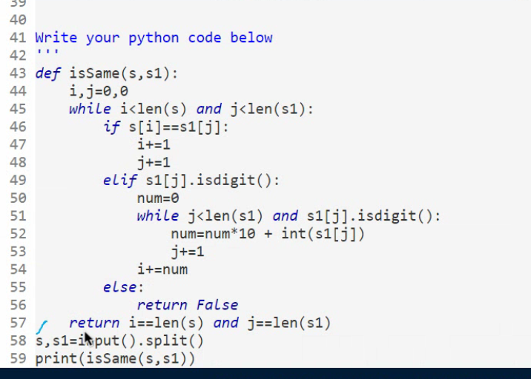

In a team of N players, each player's jersey has a number printed on it.

Jersey numbers may be repeated.

You will be given the list of jersey numbers of N players.

You need to find out number of pairs, wearing same jersey number.

i.e, pair[i]=[p1, p2], p1 and p2 are the index positions

jersey number of Player-p1 and Player-p2 should be same.

If no such pair found, print "0".

Input Format:

-------------

Line-1: An integer N, number of players.

Line-2: N space separated integers, Jersey numbers of players.

Output Format:

--------------

Print an integer, number of pairs wearing same jersey number.

Sample Input-1:

---------------

6

1 2 3 1 1 3

Sample Output-1:

----------------

4

Explanation:

------------

There are 4 pairs (0,3), (0,4), (3,4), (2,5) wearing same jersey numbers,

0-indexed list.

Sample Input-2:

---------------

3

1 2 3

Sample Output-2:

----------------

0

import java.util.\*;

public class Main{

public static void main(String[] args){

Scanner sc=new Scanner(System.in);

int n=sc.nextInt();

int[] arr=new int[n];

for(int i=0;i<n;i++){

arr[i]=sc.nextInt();

}

int count=0;

for(int i=0;i<n;i++){

int k=arr[i];

int w=0;

for(int j=i+1;j<n;j++){

// if(i!=j && !kk.contains(arr[i])){

if(arr[i]==arr[j]){

count+=1;

// System.out.println(arr[i]+"-"+i);

}

// }

}

}

System.out.println(count);

}

}